SEC Form 4
FORM 4 |  | UNITED STATES SECURITIES AND EXCHANGE COMMISSION  Washington, D.C. 20549  STATEMENT OF CHANGES IN BENEFICIAL OWNERSHIP  Filed pursuant to Section 16(a) of the Securities Exchange Act of 1934  or Section 30(h) of the Investment Company Act of 1940
  OMB APPROVAL
  OMB Number: | 3235-0287
  Estimated average burden
  hours per response: | 0.5
 | Check this box if no longer subject to Section 16. Form 4 or Form 5 obligations may continue. See Instruction 1(b).
 | Check this box to indicate that a transaction was made pursuant to a contract, instruction or written plan for the purchase or sale of equity securities of the issuer that is intended to satisfy the affirmative defense conditions of Rule 10b5-1(c). See Instruction 10.
1. Name and Address of Reporting Person*  (Street) | 2. Issuer Name and Ticker or Trading Symbol  CME GROUP INC. [ CME ]  Foreign Trading Symbol | 5. Relationship of Reporting Person(s) to Issuer  (Check all applicable)
  Vroman Ken
  (Last) | (First) | (Middle)
  20 S. WACKER DRIVE
  CHICAGO | IL | 60606
  (City) | (State) | (Zip)
   | Director |  | 10% Owner
   | Officer (give title below) |  | Other (specify below)
  Chief Transformation Officer
3. Date of Earliest Transaction (Month/Day/Year)
09/15/2026
 | 4. If Amendment, Date of Original Filed (Month/Day/Year) | 6. Individual or Joint/Group Filing (Check Applicable Line)
  Form filed by One Reporting Person
  Form filed by More than One Reporting Person
Table I - Non-Derivative Securities Acquired, Disposed of, or Beneficially Owned
1. Title of Security (Instr. 3) | 2. Transaction Date (Month/Day/Year) | 2A. Deemed Execution Date, if any (Month/Day/Year) | 3. Transaction Code (Instr. 8) |  | 4. Securities Acquired (A) or Disposed Of (D) (Instr. 3, 4 and 5) |  |  | 5. Amount of Securities Beneficially Owned Following Reported Transaction(s) (Instr. 3 and 4) | 6. Ownership Form: Direct (D) or Indirect (I) (Instr. 4) | 7. Nature of Indirect Beneficial Ownership (Instr. 4)
1. Title of Security (Instr. 3) | 2. Transaction Date (Month/Day/Year) | 2A. Deemed Execution Date, if any (Month/Day/Year) | Code | V | Amount | (A) or (D) | Price |  | 6. Ownership Form: Direct (D) or Indirect (I) (Instr. 4) | 7. Nature of Indirect Beneficial Ownership (Instr. 4)
Common Stock Class A | 09/15/2026 |  | A(1) |  | 2,592 | A | $275.09 | 21,443 | D
Common Stock Class A | 09/15/2026 |  | F(2) |  | 320 | D | $275.09 | 21,123 | D
Common Stock Class A | 09/15/2026 |  | F(2) |  | 309 | D | $275.09 | 20,814 | D
Common Stock Class A | 09/15/2026 |  | F(2) |  | 274 | D | $275.09 | 20,540 | D
Common Stock Class A | 09/16/2026 |  | F(2) |  | 308 | D | $272.46 | 20,232 | D
Table II - Derivative Securities Acquired, Disposed of, or Beneficially Owned
(e.g., puts, calls, warrants, options, convertible securities)
1. Title of Derivative Security (Instr. 3) | 2. Conversion or Exercise Price of Derivative Security | 3. Transaction Date (Month/Day/Year) | 3A. Deemed Execution Date, if any (Month/Day/Year) | 4. Transaction Code (Instr. 8) |  | 5. Number of Derivative Securities Acquired (A) or Disposed of (D) (Instr. 3, 4 and 5) |  | 6. Date Exercisable and Expiration Date (Month/Day/Year) |  | 7. Title and Amount of Securities Underlying Derivative Security (Instr. 3 and 4) |  | 8. Price of Derivative Security (Instr. 5) | 9. Number of derivative Securities Beneficially Owned Following Reported Transaction(s) (Instr. 4) | 10. Ownership Form: Direct (D) or Indirect (I) (Instr. 4) | 11. Nature of Indirect Beneficial Ownership (Instr. 4)
 |  |  |  | Code | V | (A) | (D) | Date Exercisable | Expiration Date | Title | Amount or Number of Shares
Explanation of Responses:
1. Represents a grant of restricted stock under the CME Group Omnibus Stock Plan, vesting in four equal annual installments, subject to continued service.
2. Represents shares surrendered to the Issuer to satisfy tax withholding obligations in connection with the vesting of restricted stock previously granted to the Reporting Person.
Remarks:
 | /s/ Elizabeth Hensen, as Attorney-in-Fact for Kendal Vroman | 09/17/2026
 | ** Signature of Reporting Person | Date
Reminder: Report on a separate line for each class of securities beneficially owned directly or indirectly.
* If the form is filed by more than one reporting person, see Instruction 4 (b)(v).
** Intentional misstatements or omissions of facts constitute Federal Criminal Violations See 18 U.S.C. 1001 and 15 U.S.C. 78ff(a).
Note: File three copies of this Form, one of which must be manually signed. If space is insufficient, see Instruction 6 for procedure.
Persons who respond to the collection of information contained in this form are not required to respond unless the form displays a currently valid OMB Number.
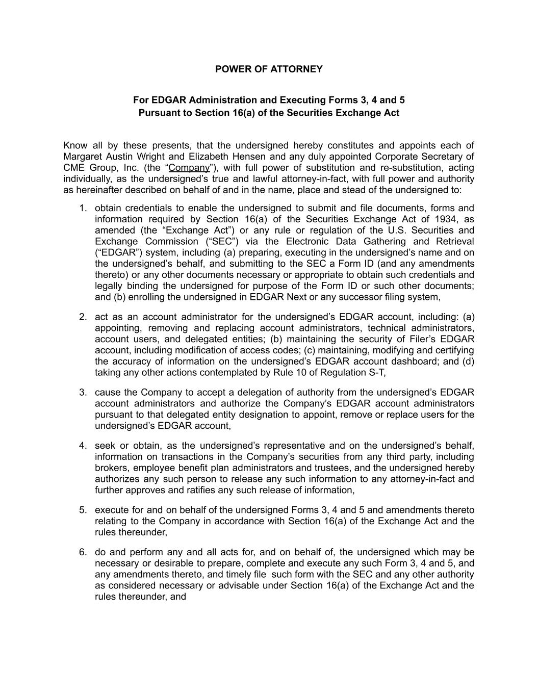
POWER OF ATTORNEY For EDGAR Administration and Executing Forms 3, 4 and 5 Pursuant to Section 16(a) of the Securities Exchange Act Know all by these presents, that the undersigned hereby constitutes and appoints each of Margaret Austin Wright and Elizabeth Hensen and any duly appointed Corporate Secretary of CME Group, Inc. (the “Company”), with full power of substitution and re-substitution, acting individually, as the undersigned’s true and lawful attorney-in-fact, with full power and authority as hereinafter described on behalf of and in the name, place and stead of the undersigned to: 1.​ obtain credentials to enable the undersigned to submit and file documents, forms and information required by Section 16(a) of the Securities Exchange Act of 1934, as amended (the “Exchange Act”) or any rule or regulation of the U.S. Securities and Exchange Commission (“SEC”) via the Electronic Data Gathering and Retrieval (“EDGAR”) system, including (a) preparing, executing in the undersigned’s name and on the undersigned’s behalf, and submitting to the SEC a Form ID (and any amendments thereto) or any other documents necessary or appropriate to obtain such credentials and legally binding the undersigned for purpose of the Form ID or such other documents; and (b) enrolling the undersigned in EDGAR Next or any successor filing system, 2.​ act as an account administrator for the undersigned’s EDGAR account, including: (a) appointing, removing and replacing account administrators, technical administrators, account users, and delegated entities; (b) maintaining the security of Filer’s EDGAR account, including modification of access codes; (c) maintaining, modifying and certifying the accuracy of information on the undersigned’s EDGAR account dashboard; and (d) taking any other actions contemplated by Rule 10 of Regulation S-T, 3.​ cause the Company to accept a delegation of authority from the undersigned’s EDGAR account administrators and authorize the Company’s EDGAR account administrators pursuant to that delegated entity designation to appoint, remove or replace users for the undersigned’s EDGAR account, 4.​ seek or obtain, as the undersigned’s representative and on the undersigned’s behalf, information on transactions in the Company’s securities from any third party, including brokers, employee benefit plan administrators and trustees, and the undersigned hereby authorizes any such person to release any such information to any attorney-in-fact and further approves and ratifies any such release of information, 5.​ execute for and on behalf of the undersigned Forms 3, 4 and 5 and amendments thereto relating to the Company in accordance with Section 16(a) of the Exchange Act and the rules thereunder, 6.​ do and perform any and all acts for, and on behalf of, the undersigned which may be necessary or desirable to prepare, complete and execute any such Form 3, 4 and 5, and any amendments thereto, and timely file such form with the SEC and any other authority as considered necessary or advisable under Section 16(a) of the Exchange Act and the rules thereunder, and

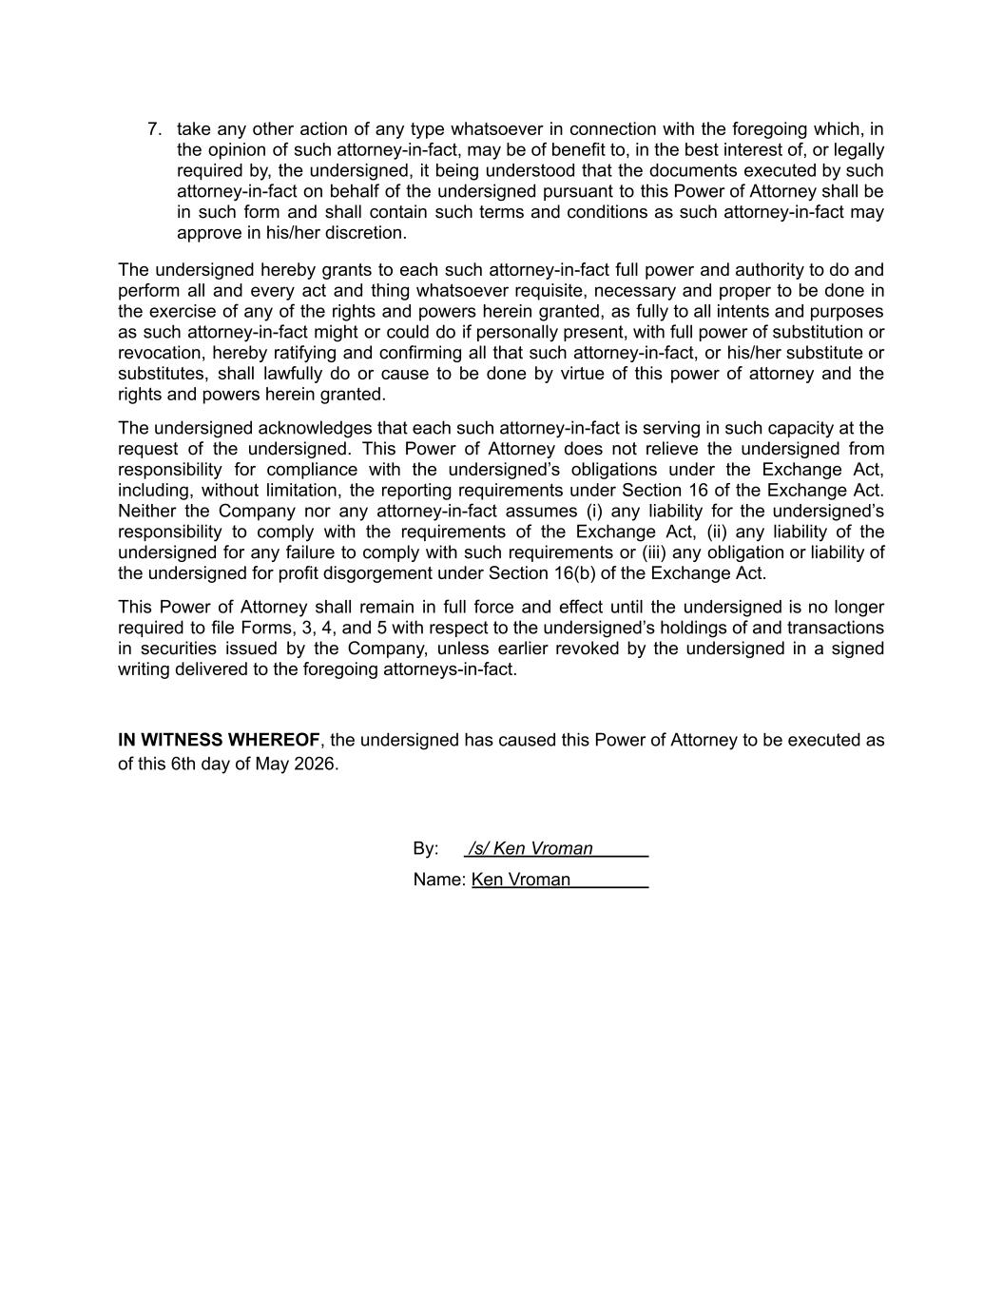
7.​ take any other action of any type whatsoever in connection with the foregoing which, in the opinion of such attorney-in-fact, may be of benefit to, in the best interest of, or legally required by, the undersigned, it being understood that the documents executed by such attorney-in-fact on behalf of the undersigned pursuant to this Power of Attorney shall be in such form and shall contain such terms and conditions as such attorney-in-fact may approve in his/her discretion. The undersigned hereby grants to each such attorney-in-fact full power and authority to do and perform all and every act and thing whatsoever requisite, necessary and proper to be done in the exercise of any of the rights and powers herein granted, as fully to all intents and purposes as such attorney-in-fact might or could do if personally present, with full power of substitution or revocation, hereby ratifying and confirming all that such attorney-in-fact, or his/her substitute or substitutes, shall lawfully do or cause to be done by virtue of this power of attorney and the rights and powers herein granted. The undersigned acknowledges that each such attorney-in-fact is serving in such capacity at the request of the undersigned. This Power of Attorney does not relieve the undersigned from responsibility for compliance with the undersigned’s obligations under the Exchange Act, including, without limitation, the reporting requirements under Section 16 of the Exchange Act. Neither the Company nor any attorney-in-fact assumes (i) any liability for the undersigned’s responsibility to comply with the requirements of the Exchange Act, (ii) any liability of the undersigned for any failure to comply with such requirements or (iii) any obligation or liability of the undersigned for profit disgorgement under Section 16(b) of the Exchange Act. This Power of Attorney shall remain in full force and effect until the undersigned is no longer required to file Forms, 3, 4, and 5 with respect to the undersigned’s holdings of and transactions in securities issued by the Company, unless earlier revoked by the undersigned in a signed writing delivered to the foregoing attorneys-in-fact. IN WITNESS WHEREOF, the undersigned has caused this Power of Attorney to be executed as of this 6th day of May 2026. ​ By: /s/ Ken Vroman​ Name: Ken Vroman​ ​

