SEC Form 4

FORM 4

Check this box if no longer subject to Section 16. Form 4 or Form 5 obligations may continue. See Instruction 1(b).

Check this box to indicate that a transaction was made pursuant to a contract, instruction or written plan for the purchase or sale of equity securities of the issuer that is intended to satisfy the affirmative defense conditions of Rule 10b5-1(c). See Instruction 10.

UNITED STATES SECURITIES AND EXCHANGE COMMISSION
Washington, D.C. 20549
Washington, D.C. 20549 |  | OMB APPROVAL
STATEMENT OF CHANGES IN BENEFICIAL OWNERSHIP
STATEMENT OF CHANGES IN BENEFICIAL OWNERSHIP |  | OMB Number: | 3235-0287
 |  | Estimated average burden
Filed pursuant to Section 16(a) of the Securities Exchange Act of 1934 |  | hours per response: | 0.5
or Section 30(h) of the Investment Company Act of 1940
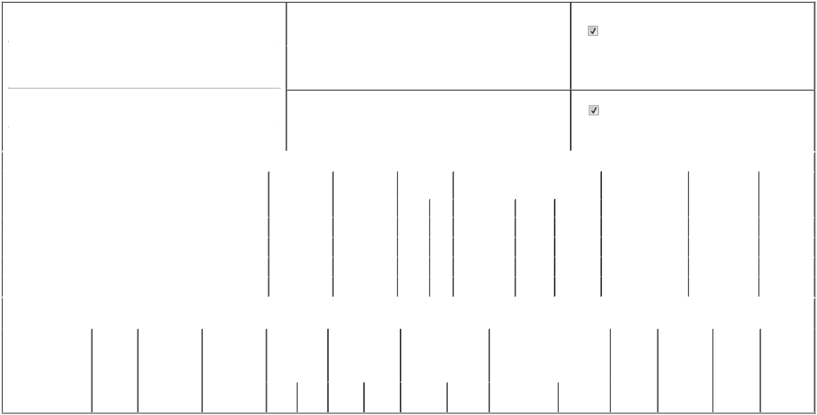

1. Name and Address of Reporting Person* |  |  |  |  |  |  | 2. Issuer Name and Ticker or Trading Symbol
 | Hobert William W |  |  |  |  |  | CME GROUP INC. [ CME ]
 | (Last) | (First) |  | (Middle) |  |  | 3. Date of Earliest Transaction (Month/Day/Year)
 | 20 S. WACKER DRIVE |  |  |  | 05/01/2026

- Relationship of Reporting Person(s) to Issuer (Check all applicable)

Director | 10% Owner
Officer (give title | Other (specify below)
below) | Other (specify below)

 | (Street) |  |  |  |  |  | 4. If Amendment, Date of Original Filed (Month/Day/Year) |  |  |  |  |  |  |  | 6. Individual or Joint/Group Filing (Check Applicable Line)
 |  | CHICAGO | IL | 60606 |  |  |  |  |  |  |  |  |  |  |  |  | Form filed by One Reporting Person
 |  |  |  |  |  |  |  |  |  |  |  |  |  |  |  |  | Form filed by More than One Reporting Person
 |  | (City) | (State) | (Zip)
 |  |  |  |  | Table I - Non-Derivative Securities Acquired, Disposed of, or Beneficially Owned
 | 1. Title of Security (Instr. 3) |  |  |  |  | 2. Transaction |  | 2A. Deemed |  | 3. Transaction |  | 4. Securities Acquired (A) or Disposed Of |  |  |  | 5. Amount of Securities |  |  | 6. Ownership |  | 7. Nature of
 |  |  |  |  |  | Date |  | Execution Date, |  | Code (Instr. 8) |  | (D) (Instr. 3, 4 and 5) |  |  |  | Beneficially Owned |  |  | Form: Direct (D) or |  | Indirect
 |  |  |  |  |  | (Month/Day/Year) |  | if any |  |  |  |  |  |  |  | Following Reported |  |  | Indirect (I) (Instr. 4) |  | Beneficial
 |  |  |  |  |  |  |  | (Month/Day/Year) |  | Code | V | Amount |  | (A) or (D) | Price | Transaction(s) (Instr. 3 |  |  |  |  | Ownership
 |  |  |  |  |  |  |  |  |  | Code | V | Amount |  | (A) or (D) | Price | and 4) |  |  |  |  | (Instr. 4)
 | Common Stock Class A |  |  |  |  | 05/01/2026 |  |  |  | J |  | 20,320 |  | D | (1) | 19,680 |  |  |  | I | By Firm
 | Common Stock Class A |  |  |  |  | 05/01/2026 |  |  |  | J |  | 20,320 |  | A | (1) | 106,938.531⁽²⁾ |  |  |  | D
 | Common Stock Class A |  |  |  |  | 06/25/2026 |  |  |  | _{A}(3) |  | 645 |  | A | $225 | 107,583.531 |  |  |  | D
 | Common Stock Class A |  |  |  |  | 06/25/2026 |  |  |  | _{A}(4) |  | 422 |  | A | $225 | 108,005.531 |  |  |  | D
 |  |  |  |  | Table II - Derivative Securities Acquired, Disposed of, or Beneficially Owned
 |  |  |  |  |  | (e.g., puts, calls, warrants, options, convertible securities)
 | 1. Title of Derivative |  | 2. | 3. Transaction | 3A. Deemed | 4. Transaction |  | 5. Number of |  | 6. Date Exercisable and |  |  | 7. Title and Amount of Securities |  |  |  | 8. Price of | 9. Number of |  | 10. | 11. Nature of
 | Security (Instr. 3) |  | Conversion | Date | Execution Date, | Code (Instr. 8) |  | Derivative |  | Expiration Date |  |  | Underlying Derivative Security |  |  |  | Derivative | derivative |  | Ownership | Indirect
 |  |  | or Exercise | (Month/Day/Year) | if any |  |  | Securities Acquired |  | (Month/Day/Year) |  |  | (Instr. 3 and 4) |  |  |  | Security | Securities |  | Form: | Beneficial
 |  |  | Price of |  | (Month/Day/Year) |  |  | (A) or Disposed of |  |  |  |  |  |  |  |  | (Instr. 5) | Beneficially |  | Direct (D) or | Ownership
 |  |  | Derivative |  |  |  |  | (D) (Instr. 3, 4 and |  |  |  |  |  |  |  |  |  | Owned |  | Indirect (I) | (Instr. 4)
 |  |  | Security |  |  |  |  | 5) |  |  |  |  |  |  |  |  |  | Following |  | (Instr. 4)
 |  |  |  |  |  |  |  |  |  |  |  |  |  |  |  |  |  | Reported
 |  |  |  |  |  |  |  |  |  |  |  |  |  |  | Amount or |  |  | Transaction(s)
 |  |  |  |  |  |  |  |  |  | Date |  | Expiration |  |  | Number of |  |  | (Instr. 4)
 |  |  |  |  |  | Code V |  | (A) | (D) | Exercisable |  | Date | Title |  | Shares

Explanation of Responses:

- Represents a pro-rata, in-kind distribution of Class A Common Stock by WH Trading LLC to the Reporting Person for no consideration in a transaction exempt under Rule 16a-13. The Reporting Person received 20,320 shares in his individual capacity, which are now held directly. Previously, such shares were reported as being held indirectly by the Reporting Person. Effective May 1, 2026, the Reporting Person is no longer the managing member of WH Trading LLC. As a result of his retirement, the Reporting Person no longer shares voting or dispositive power over, or holds a reportable pecuniary interest in, the shares held of record by WH Trading LLC.

- The amount of securities beneficially owned reported in Column 5 has been adjusted to reflect an administrative tracking true-up of 20.531 shares due to a cumulative clerical error in the calculation of historical balances. This adjustment reflects the Reporting Person's actual beneficial ownership as of the date of this filing.

- Represents a grant of fully vested shares of Class A Common Stock issued to the Reporting Person as part of the Issuer's annual equity compensation program for non-employee directors under the CME Group Director Stock Plan. These shares are not subject to any vesting conditions.

- At the Reporting Person's election, shares issued in lieu of all or a portion of the annual cash retainer for serving as a member of the Board of Directors. The number of shares was determined by dividing the cash retainer by the closing price on the date of grant.

Remarks:

 | /s/ Elizabeth Hensen, as Attorney-in- |  |  | 06/29/2026
 | Fact for William W. Hobert
 | ** Signature of Reporting Person |  |  | Date
Reminder: Report on a separate line for each class of securities beneficially owned directly or indirectly.
* If the form is filed by more than one reporting person, see Instruction 4 (b)(v).
** Intentional misstatements or omissions of facts constitute Federal Criminal Violations See 18 U.S.C. 1001 and 15 U.S.C. 78ff(a).
Note: File three copies of this Form, one of which must be manually signed. If space is insufficient, see Instruction 6 for procedure.
Persons who respond to the collection of information contained in this form are not required to respond unless the form displays a currently valid OMB Number.



